

Name: Mohamed Saleh Abbashar
ID: 1111113245
Tutorial Section: TC203
Tutor's Name: Wong Ya Ping
Program: Triple Character

About the Program

This program main purpose is to illustrate the logic or the main idea behind "Triple town" the game ... so its triple town game but simpler than the real thing and you don't build a town,we use English character instead of graphic,so, we build a new characters..

The board of this game is consist of 5x5 columns and rows. The computer will choose a character for you [A,B,C,D] so, you can add them to the board. You should add a row number then a column number to choose the square that you want to add a character to.

I would like to call this game “Triple Character” instead of “Triple Town” because in it we are not going to try to build a big town we try to get as much 'D' and 'E' as we can in board.

The code

In this code I tried to use classes, my class name was “game” . Inside this class there were many functions { Reset();Display(); InputChecking(); showRchar(); squance();
Score();}

- Menu function: show the menu before starting the game
, in the menu you can choose one from two options; to see whats this game about and start the game or to exit from it.
- Display function: show the board of the game using nested for loop with an array
- Reset function: clear the board by using the same nested for loop with “ ” space.
- InputChecking function: check whether the input (row number, column number) are integer. Not more then 5 and not less than 1. The character "which is given by using rand()" is between “a,b,c.d,e,f,g”
.
- Squance function: change from "A" to "B" whenever there are three "A's" together near each other by using nested for loop with many while loops.
- About function: show some stuff about (this function is made to make Menu function smaller ) its called by Menu function.
- ShowRchar function: show a random characters in a random places in the board to add more challenge to the game.
- Score function: to count the score.

Manual (Screen shots)

1) main menu of the game (I know very simple to call it menu)
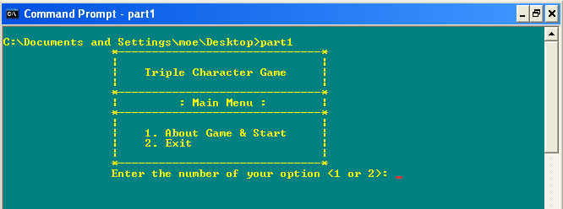

2) you choose the first option to start the game , but before you start it will tell you more about it
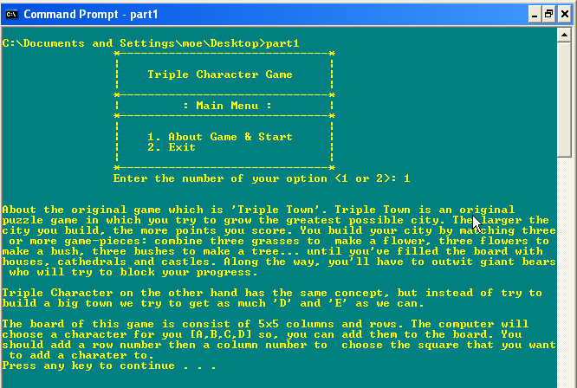

3) The board game appeared for you with a random characters for more challenging , but first you have to choose row number and column number (square) .

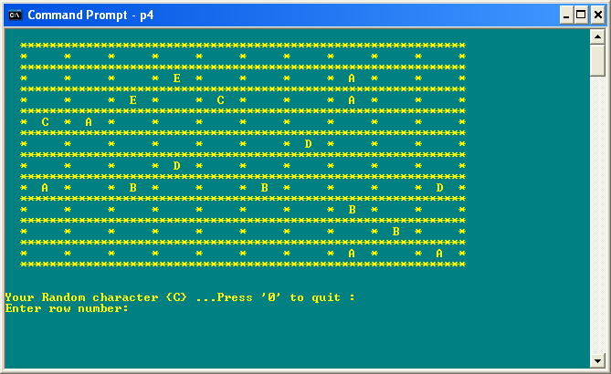

4) the character “C” will directly by inserted in the third row and first column as we did in step 3.

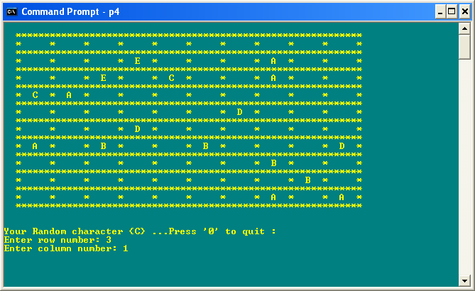

5) Try to get as much F’s and G’s as possible because they have the highest score.

